**CANNON BEACH FIRE PROTECTION DISTRICT**

**WILDFIRE PREPAREDNESS NIGHT**

**TUESDAY 5:30 PM- 7:30PM**

**JUNE 24, 2025**

**CANNON BEACH LIBRARY**

**131 N Hemlock St, Cannon Beach, OR 97110**

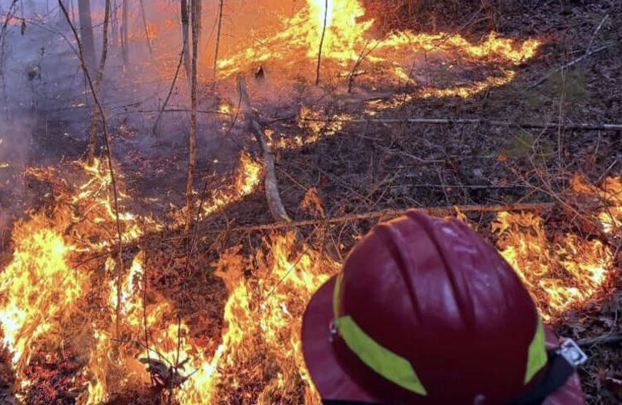

COME MEET THE CANNON BEACH FIRE MARSHAL ALONG WITH THE EMERGENCY MANAGERS FROM THE CITY OF CANNON BEACH AND PACIFIC POWER.

**LEARN** ABOUT THE PREDECTIONS FOR THE UPCOMING WILDFIRE SEASON.

**DISCOVER** HOW TO INCREASE DEFENSIBLE SPACE AROUND YOUR HOUSE. **SIGN UP** FOR EMERGENCY NOTIFICATIONS DURING WILDFIRES AND OTHER EMERGENCIES.

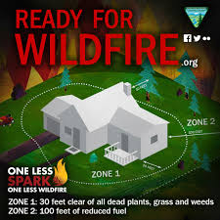**UNDERSTAND** HOW PACIFIC POWER MANAGES POWER DELIVERY DURING A WILDFIRE EMERGENCY.

Please join us for this multi-jurisdictional effort and share your priorities and concerns about wildfires.

To learn more about this meeting or to RSVP, please contact John Jerome, Cannon Beach Fire Marshal 503-436-2949, or [jjerome@cbfire.com](mailto:jjerome@cbfire.com). [www.cbfire.com](http://www.cbfire.com) or

Andy Murray, City of Cannon Beach Emergency Manager

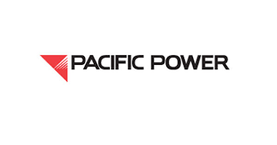503-436-8055 Andrew Murray [murray@ci.cannon-beach.or.us](mailto:murray@ci.cannon-beach.or.us)

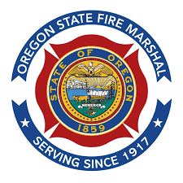

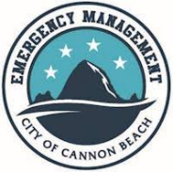 PROGRAM SPONSORS