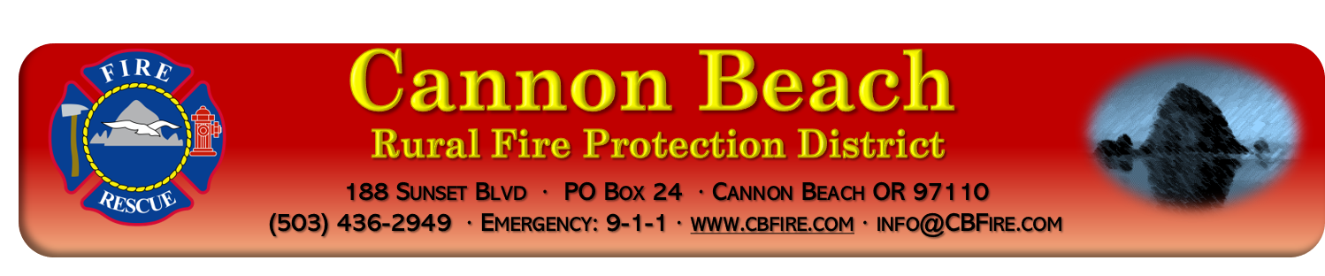
Board of Directors
Budget Hearing- June 8th, 2026, at 6:00PM
Fire Station Board Room – 188 Sunset Boulevard, Cannon Beach, OR
MINUTES

- Call to Order
  - Presiding: Dave Herman – Call to order 6:00pm
  - Recording Executive Assistant: Karen Paino
  - Directors Present: Heidi Dethloff, Jenee Pearce-Mushen, Dave Herman
  - Staff Present: DC Jason Smith, Fire Marshal John Jerome, Greg Munn
- Approve Agenda –
- Motion: Approve Agenda
Moved: Jenee Pearce-Mushen | Second: Heidi Dethloff | Approved 3-0

- Public Comment – none

- Board of Director’s Comments –

    - Heidi Dethloff –
    - Jenee Pearce-Mushen –
    - Dave Herman –

- Meeting adjourned at – 6:05pm

