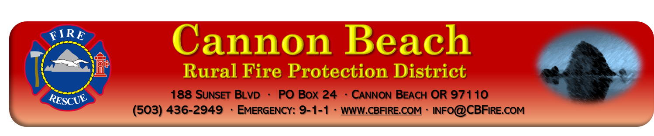
MEETING AGENDA November 14, 2022
(2nd Monday of every month) 1800hrs (6pm)
Join in person or on zoom
*Board may go into Executive Session per ORS 192.660 as needed*
- Call to Order
- Roll call
- Changes to Agenda
- Public Comment
- Approval of October 10th Board Meeting Minutes
- Treasurer’s Report
- Bills
- Correspondence
- Monthly review of board policies
- Call response
- Old Business
  - Strategic Plan
  - Volunteer housing
  - Banking changes
  - Civil Service Commission
- New Business
  - Surplus 1993 Ford Brush
  - Review of finding of facts for approval of CM/GC
    - Motion to approve the use of Construction Management/General Contractor method of construction contracting.
- Reports
  - Chief’s Report
  - Division Chief report
  - Board of Directors
    - Cerelli
    - Herman
    - Gardner
    - Bell
    - Heymann
- Good of the Order/Public Comment
- Adjourn---
- Next Board Meeting, December 12, 2022POSTED: 11/08/2022
Zoom information
https://zoom.us/j/96909730187
Meeting ID: 969 0973 0187
+1 253 215 8782 US (Tacoma)

