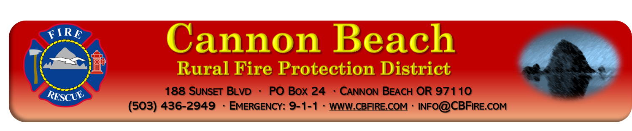
MEETING AGENDA October 10, 2022
(2nd Monday of every month) 1800hrs (6pm)
Join in person or on zoom
*Board may go into Executive Session per ORS 192.660 as needed*
- Call to Order
- Roll call
- Changes to Agenda
- Public Comment
- Approval of September 12th Board Meeting Minutes
- Treasurer’s Report
- Bills
- Correspondence
- Monthly review of board policies
- Call response
- Old Business
  - Strategic Plan
  - Volunteer housing
  - Banking changes
  - Civil Service Commission
- New Business
  - Surplus of 2004 jet skis
  - Surplus 1995 Pierce engine (3227)
- Reports
  - Chief’s Report
  - Division Chief report
  - Board of Directors
    - Cerelli
    - Herman
    - Gardner
    - Bell
    - Heymann
- Good of the Order/Public Comment
- Adjourn---
- Next Board Meeting, November 14th, 2022POSTED: 10/04/2022
Zoom information
https://zoom.us/j/96909730187
Meeting ID: 969 0973 0187
+1 253 215 8782 US (Tacoma)

